# Bug 2 Test Investigation/Fix Log

## Hypothesis

That because the method Player.takeBet() (called by method Game.playRound()) is where the limit is checked against the player’s balance it is therefore the source of the bug in which the limit can never be reached.

## Action 1: Test Hypothesis

Place breakpoints into the Player.takeBet() method and the Player.balanceExceedsLimitBy() method to observe the content of variables for limit, balance, and bet.

## Results of Test

Investigation into Bug 2 shows that because the balance is checked against the limit (and an exception thrown if the balance minus the bet is not greater than the limit) *before the balance is reduced by the bet amount*, the last bet can never be used. So, when the game progresses to a point where the balance only contains enough for a single last bet, the game will end with the exception message “Placing bet would go below limit” and the balance will always remain equal to the amount of a single bet.

See screenshots below:

Screenshot 1 – code in Player.takeBet() and Player.balanceExceedsLimitBy() showing breakpoints:

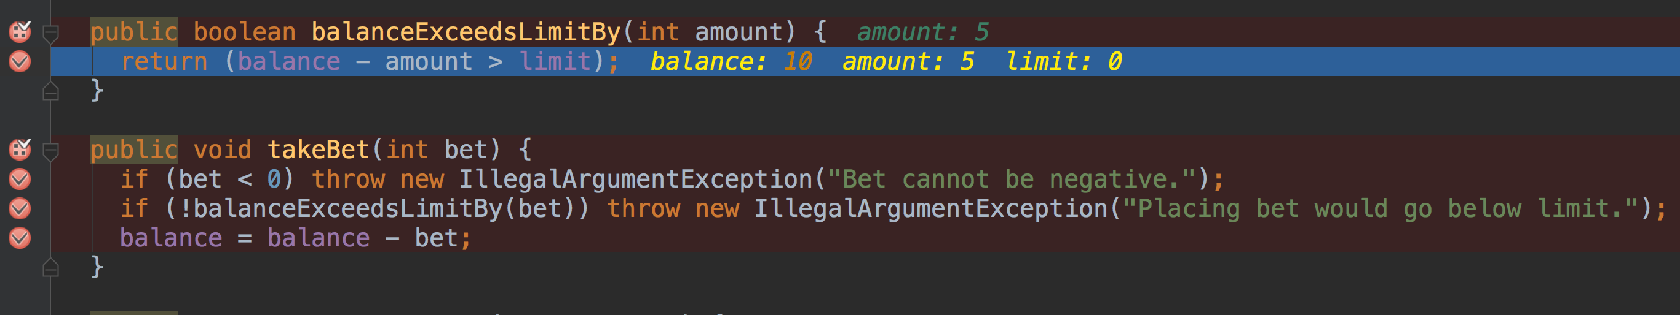

Screenshot 2 – variables show values when balance = 10 and bet = 5:

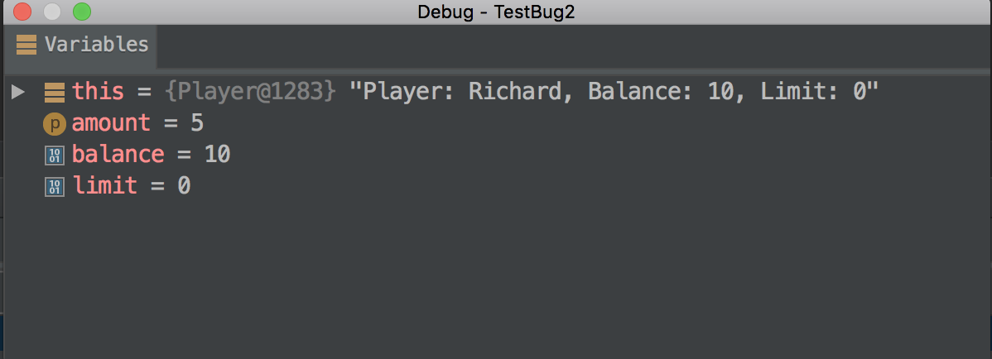

Screenshot 3 – console output at time when balance = 10 and bet = 5:

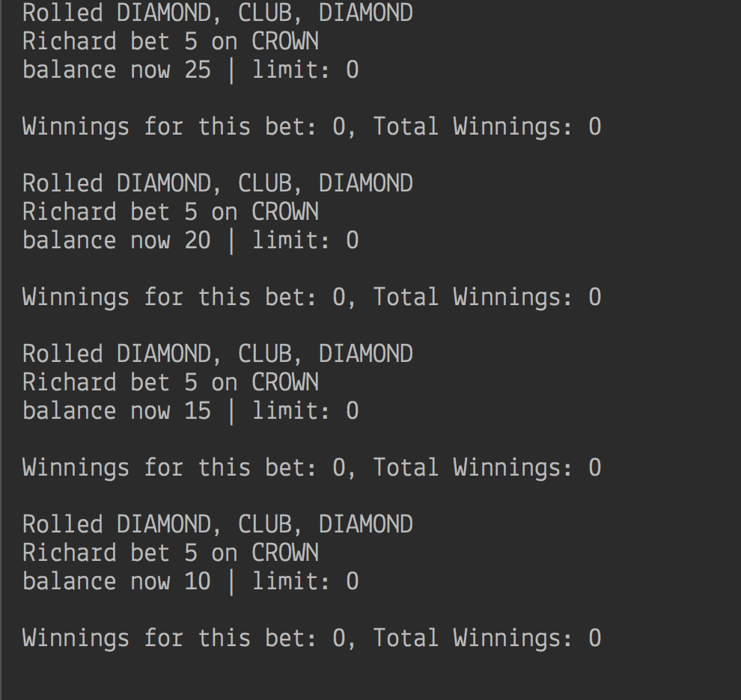

Screenshot 4 – code in Player.takeBet() showing breakpoints when balance = 5:

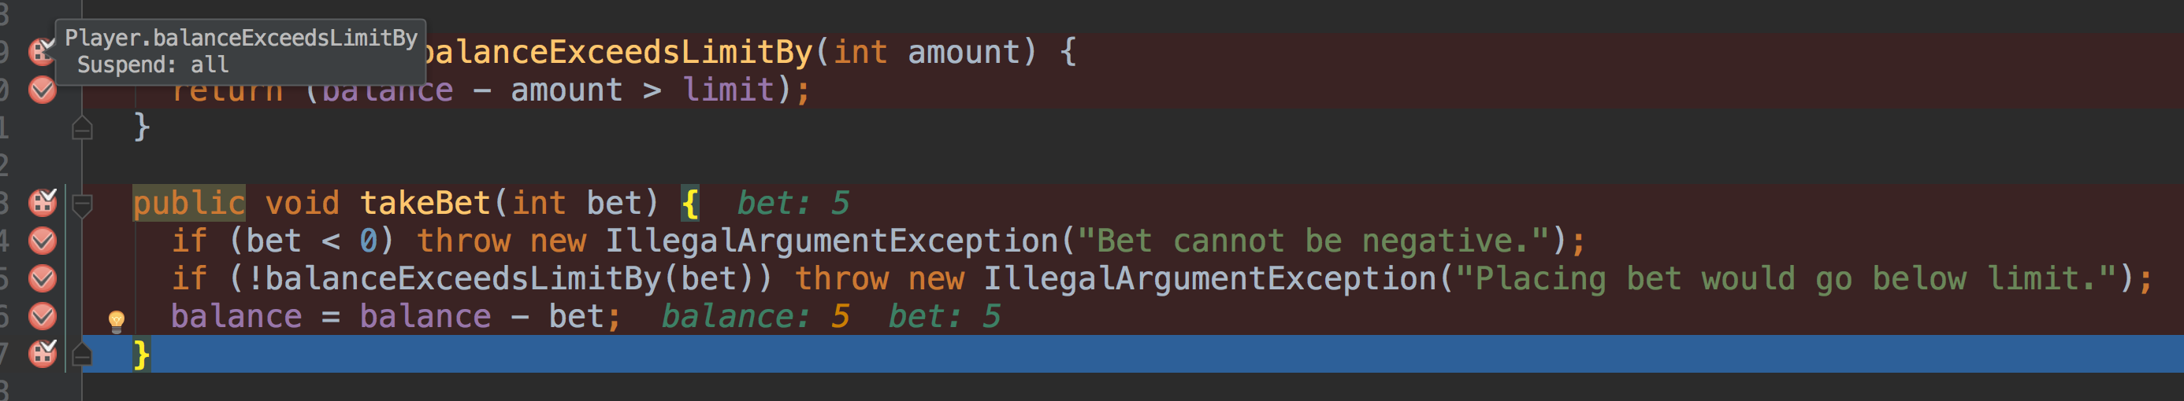

Screenshot 5 – variables showing values when balance = 5:

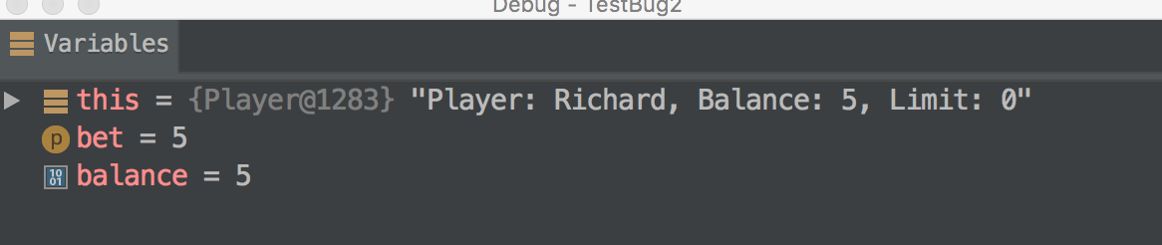

Screenshot 6 – code in Player.balanceExceedsLimitBy() when balance = 5:

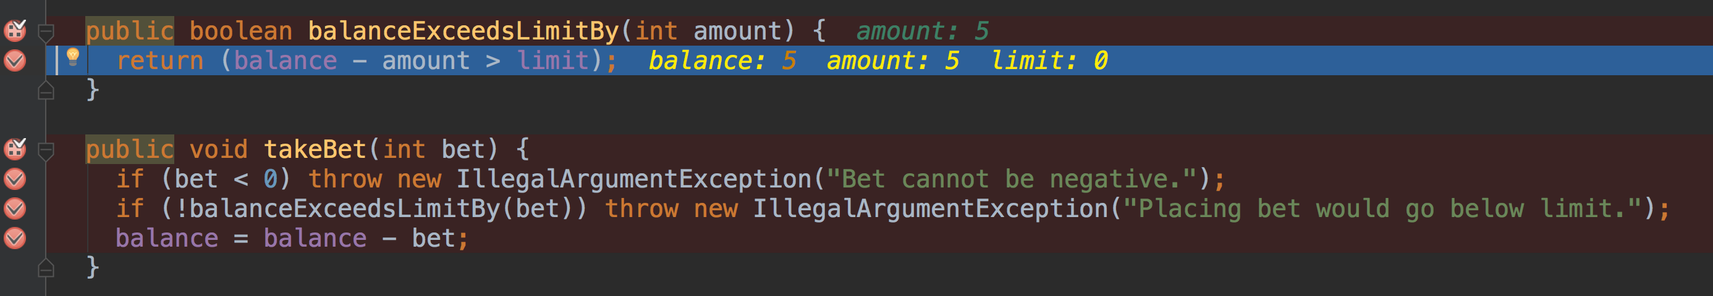

Screenshot 7 – variables showing values when balance = 5 and Player.balanceExceedsLimitBy() is being executed: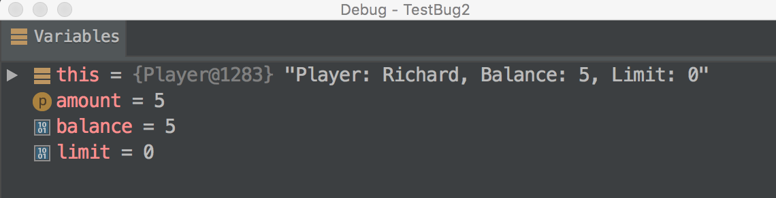

Screenshot 8 – console output showing exception message and balance remaining at 5:

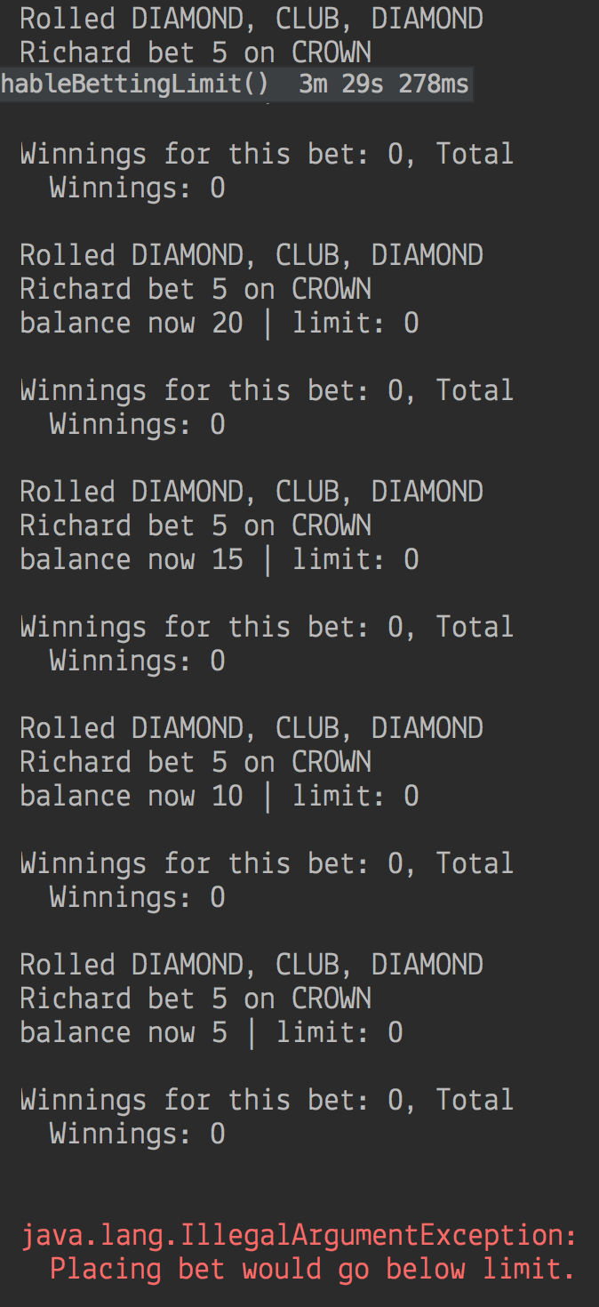

## Action 2: Fix Code

The code in Player class was modified to fix Bug 2 – see code change in repository “Zapp”. The check within Player.balanceExceedsLimit was changed to remove the subtraction of the bet amount.

## Action 3: Test Fixed Code

The fix resulted in the balance now reaching the limit (which was set to zero in this test). As can be seen in the screenshot below, the balance now reaches zero and the exception message is thrown when the player attempts to bet beyond the limit.

Screenshot 9 – console output showing balance equal to limit:

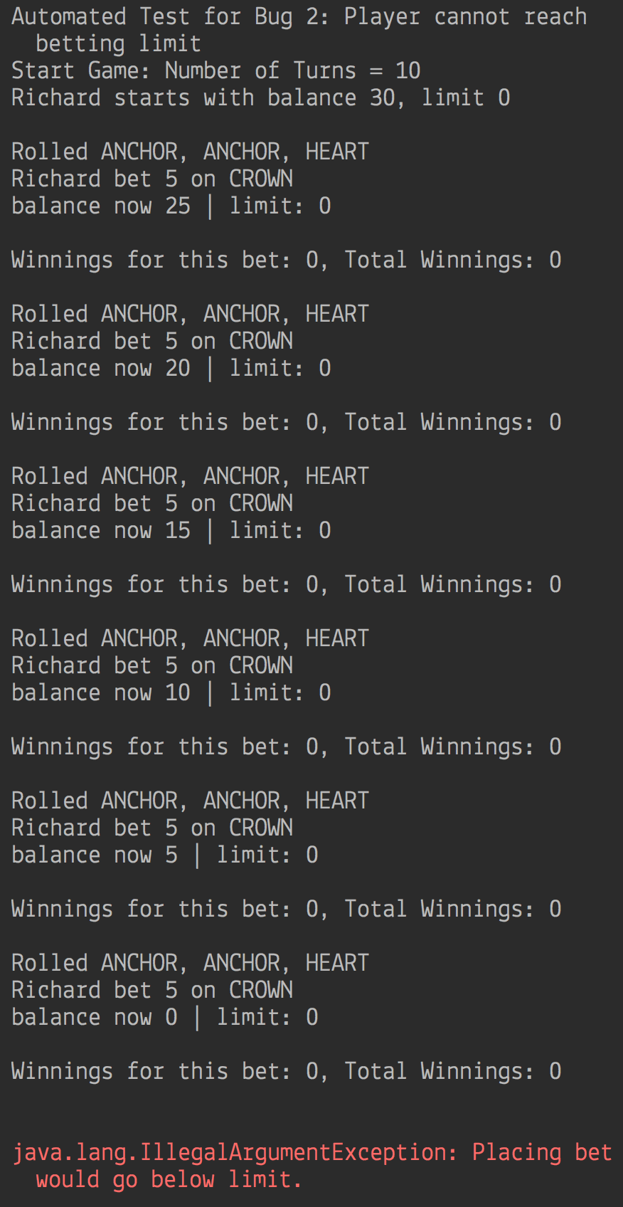

## Results of Test

The test results prove the hypothesis and show the bug is now fixed.